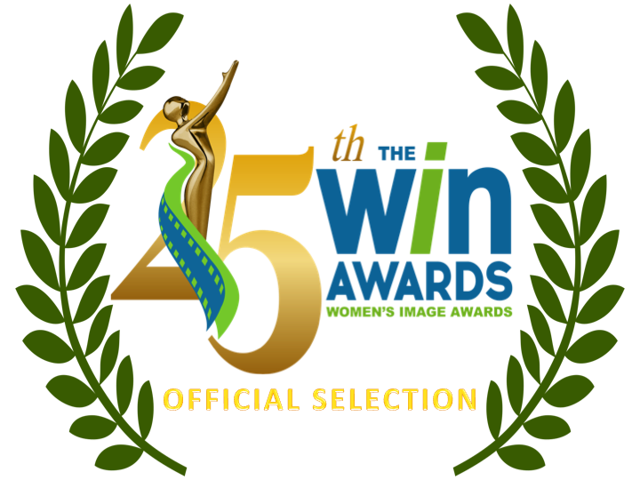

Made For Television Movie / Limited Series
Sneakerella
A Small Light
Daisy Jones & The Six
Reba McEntire’s The Hammer

Actress Made For Television Movie / Limited Series
Bel Powley A Small Light
Riley Keough Daisy Jones & The Six
Lexi Underwood Sneakerella
Jemima Rooper Flowers In The Attic: The Origin

Documentary Film (Short)
Anastasia
Angola Do You Hear Us? Voices From A Plantation Prison
More Than I Want To Remember
As Far As They Can Run

Documentary Film (Feature Length)
The Fire That Took Her
Fire of Love
TLC Forever
Wild Life
Jeanette Lee Vs.

Comedy Writers
Annabel Oakes Grease: Rise of The Pink Ladies “We’re Gonna Rule the School”
Sarah LaBrie Blindspotting “By Hook Or By Crook”
Jenny Bicks Welcome to Flatch “Welcome to (Barb) Flatch”
Awkwafina, Teresa Hsiao Awkwafina is Nora From Queens “Nora is Awkwafina From Queens”

Drama Writers
Joan Rater A Small Light “Pilot”
Dawn M. Kamoche, Ariella Blejer, Justin Haythe The Serpent Queen “The Last Joust”
Heather Zuhlke BMF “Family Business”
Ashley Victoria Hudson, Brett Mahoney Power Book II: Ghost “Your Perception, Your Reality”

Film Directors
Tanaz Eshaghian As Far As They Can Run
Sara Dosa Fire of Love
Laura Checkoway The Cave of Adullam
Ondi Timoner Last Flight Home
Patricia E. Gillespie The Fire That Took Her
(more)
Series Directors
Susanna Fogel A Small Light “Pilot”
Awkwafina Awkwafina is Nora From Queens “Nightmares”
Christina Alexandra Voros Yellowstone “One Hundred Years Is Nothing”
Stacie Passon The Serpent Queen “Medici Bitch”
Alethea Jones Grease: Rise of The Pink Ladies “We're Gonna Rule the School”

Comedy Series
Single Drunk Female “Grant Me the Serenity”
Awkwafina is Nora From Queens “Nora is Awkwafina From Queens”
Grease: Rise of The Pink Ladies “We’re Gonna Rule the School”
Party Down “Once Upon A Time “Proms Away” Prom-otional Event”
Welcome to Flatch “Welcome to (Barb) Flatch”

Actress Comedy Series
Grace Palmer Animal Control “Peacocks and Pumas”
Awkwafina Awkwafina is Nora From Queens “Nora is Awkwafina From Queens” Jaime Pressly Welcome to Flatch “Welcome to (Barb) Flatch”
Jaylen Barron Blindspotting “Meatfest”
Jane Lynch Party Down “Once Upon A Time “Proms Away” Prom-otional Event”

Drama Series
1923 “Pilot”
The Serpent Queen “Medici Bitch”
Power Book III: Raising Kanan “If Y’Don’t Know, Now Y’Know”
National Treasure: Edge of History “The Treasure Map”
Good Trouble “Shot in the Dark”

Actress Drama Series
Patina Miller Power Book III: Raising Kanan “If Y’Don’t Know, Now Y’Know”
Samantha Morton The Serpent Queen “Medici Bitch”
Aminah Nieves 1923 (Pilot)
Loretta Devine P-Valley “Jackson”
Helen Mirren 1923 (Pilot)

Film / Show Producers
Stacie Passon The Serpent Queen “Medici Bitch”
Courtney A. Kemp, Shana Stein Power Book III: Raising Kanan “If Y’Don’t Know, Now Y’Know”
Elizabeth Chai Vasarhelyi Wild Life
Cheryl Nichols Keep This Between Us “Passing The Trash”
Sara Dosa Fire of Love

Reality Series
Restaurants at the End of the World “Panama's Cloud Forest Kitchen”
Growing Up “Amiri”

Actress Reality Series
Kamie Crawford Catfish: The TV Show “Ivy and Dante”
Dr. Sandra Lee Dr. Pimple Popper
Nicole "Snooki" Polizzi Jersey Shore Family Vacation “Operation Mike Drop”

(more)
Animated Series
Entergalactic
HouseBroken

Actress Animated Series
Clea DuVall HouseBroken "Who’s Obsessed?"
Jessica Williams Entergalactic

